Remix IDE screenshots:

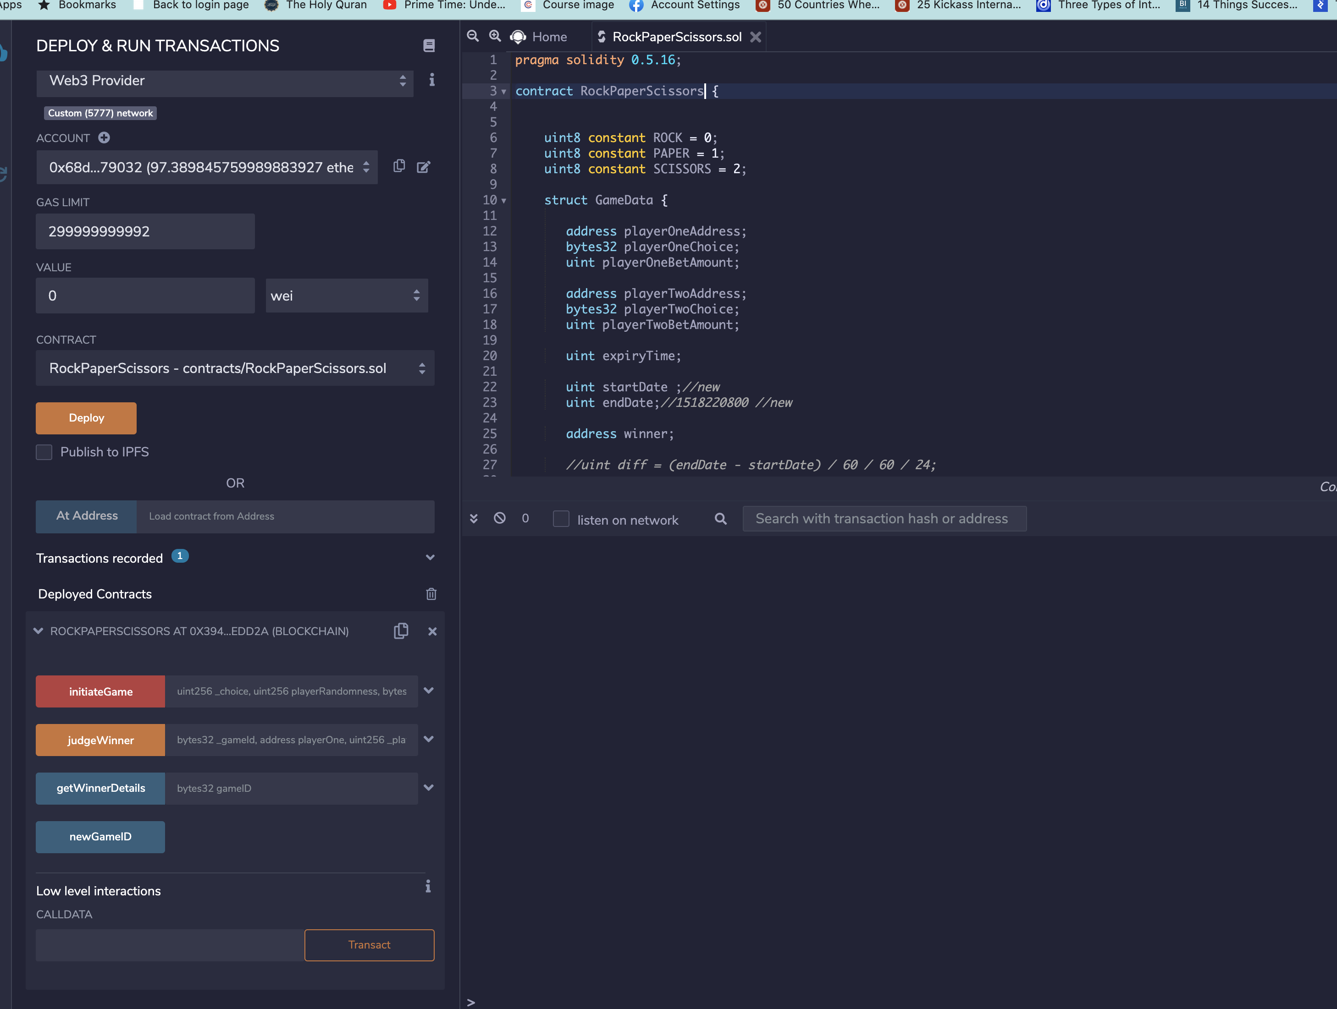

Initiate game:

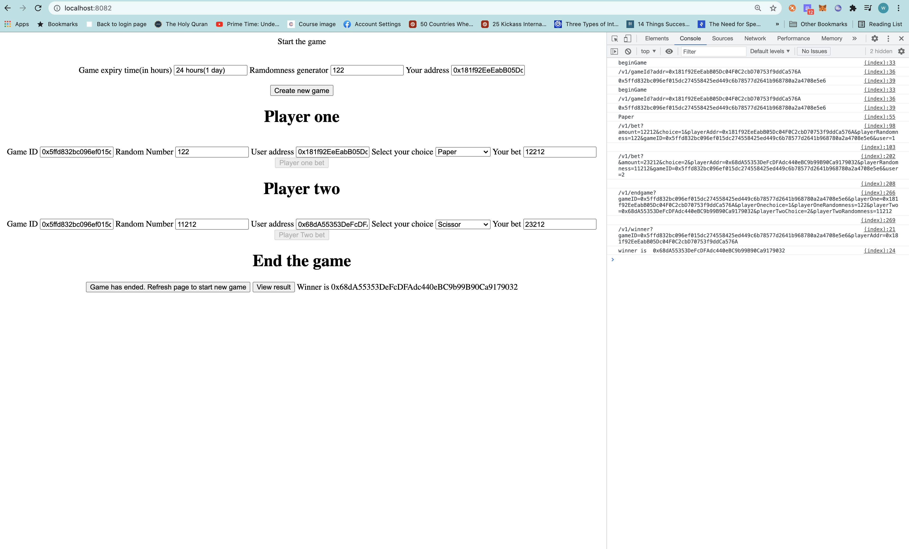

Smart contract execution [Remix IDE]

Deploying smart contract:

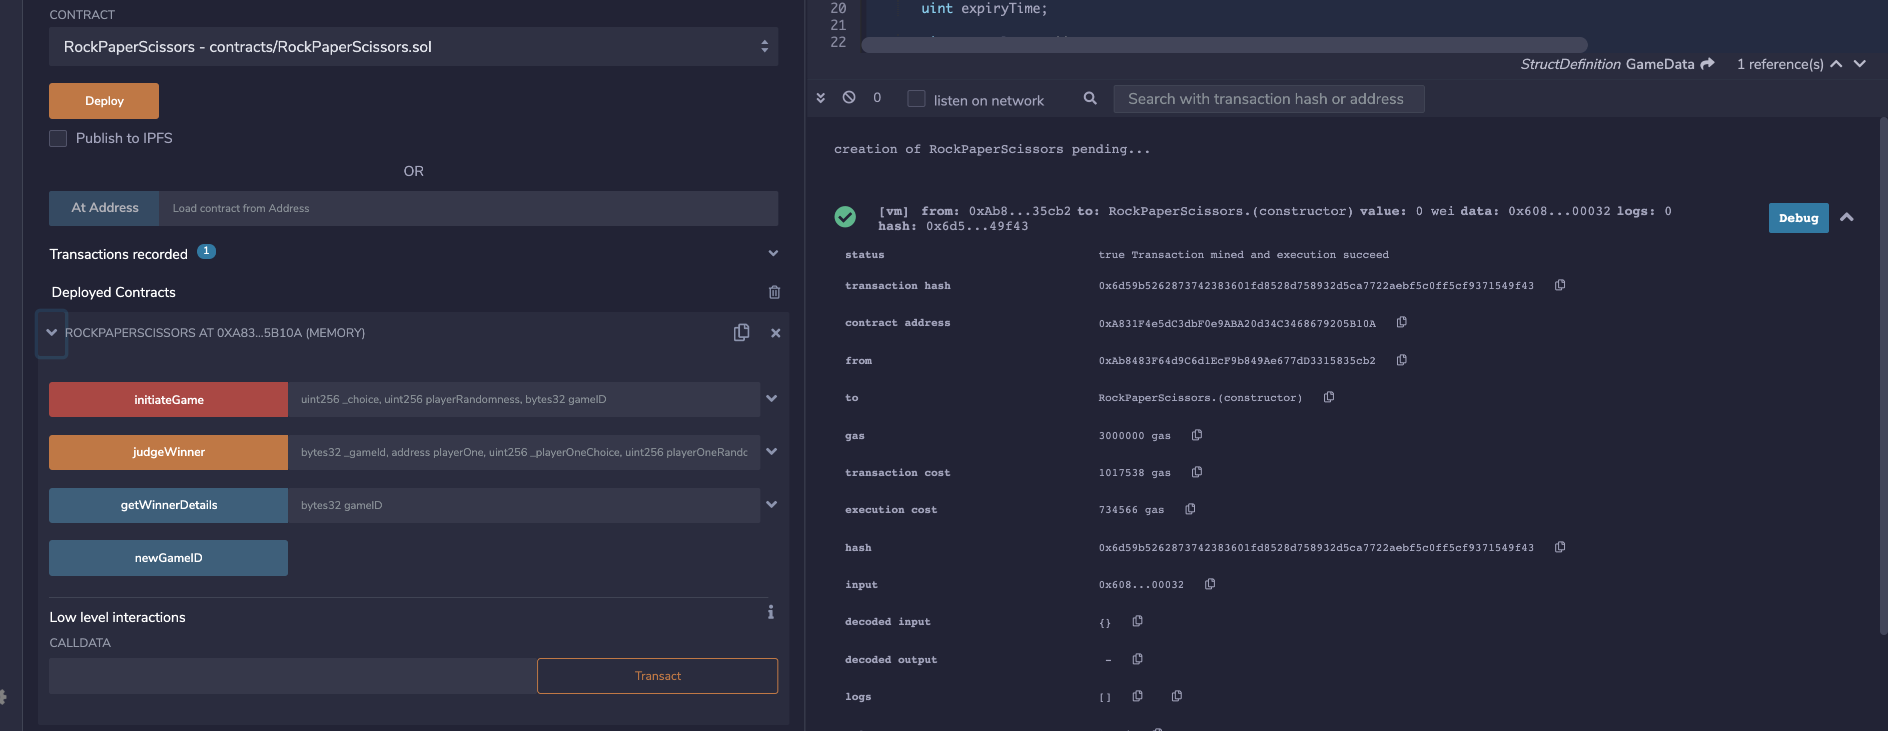

Starting game by generating the gameid:

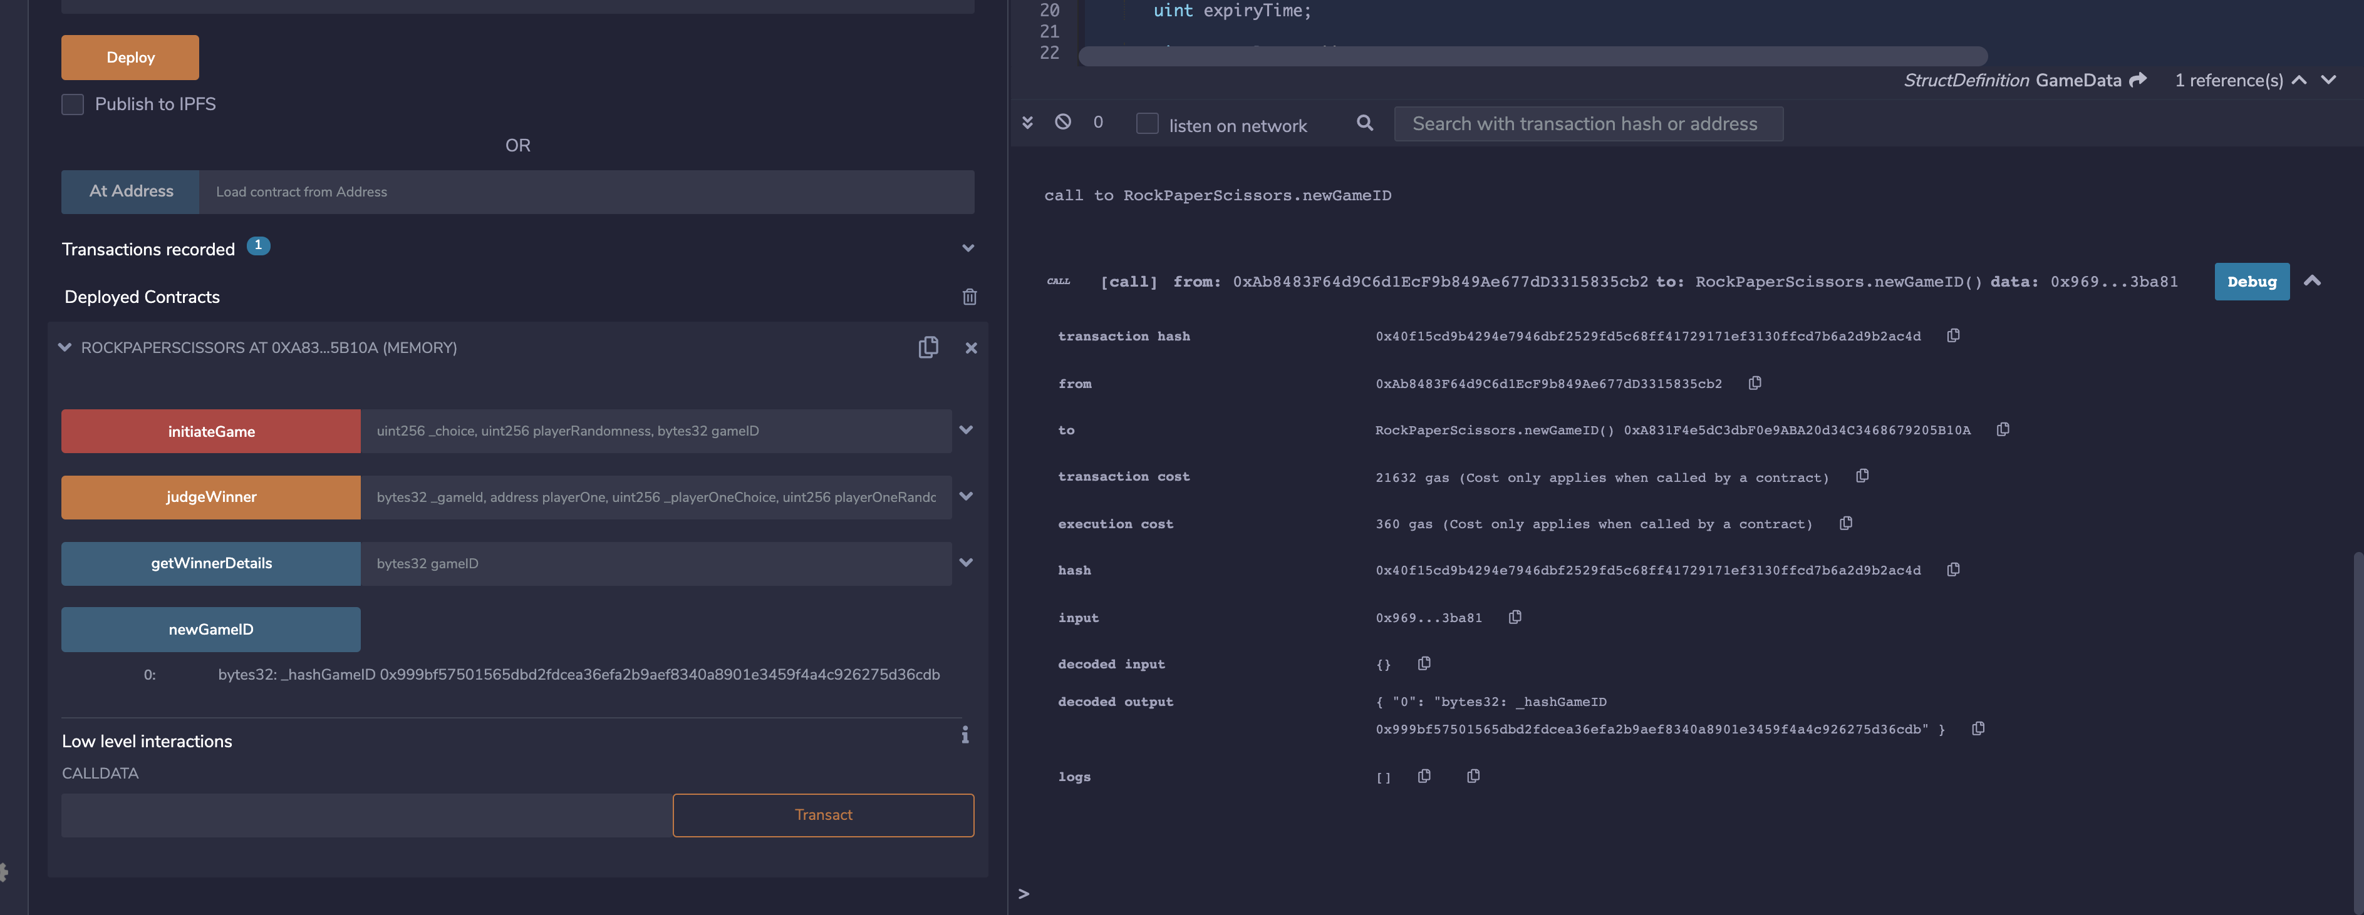

Placing bet:

**Player 1 addr 0xAb8483F64d9C6d1EcF9b849Ae677dD3315835cb2**

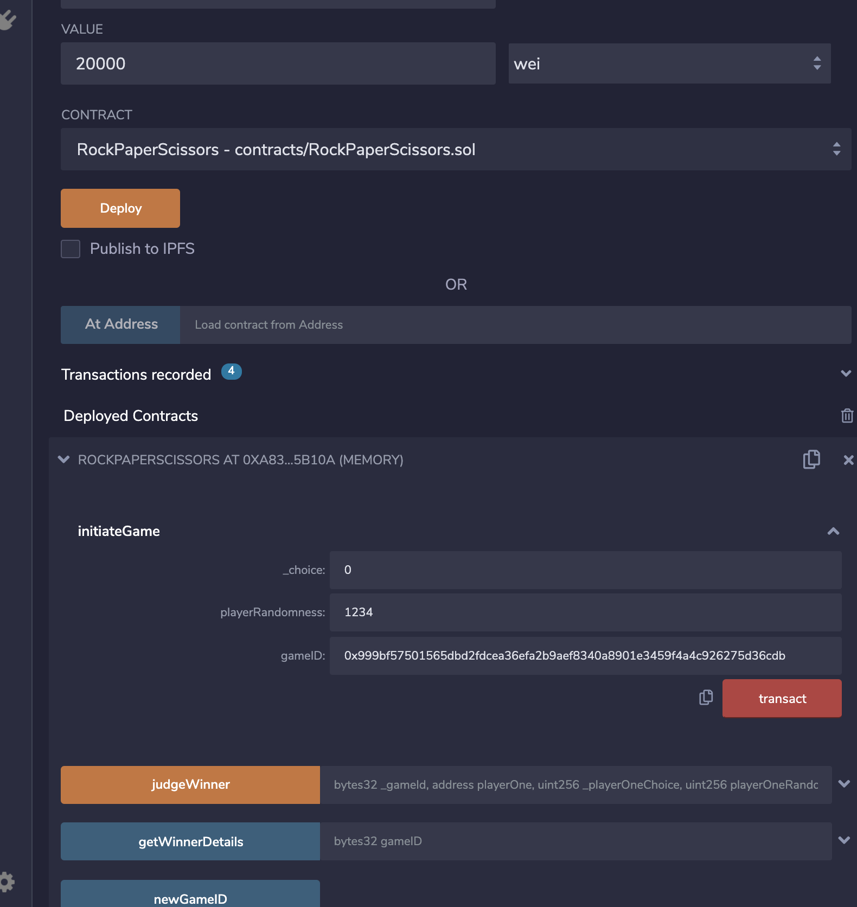

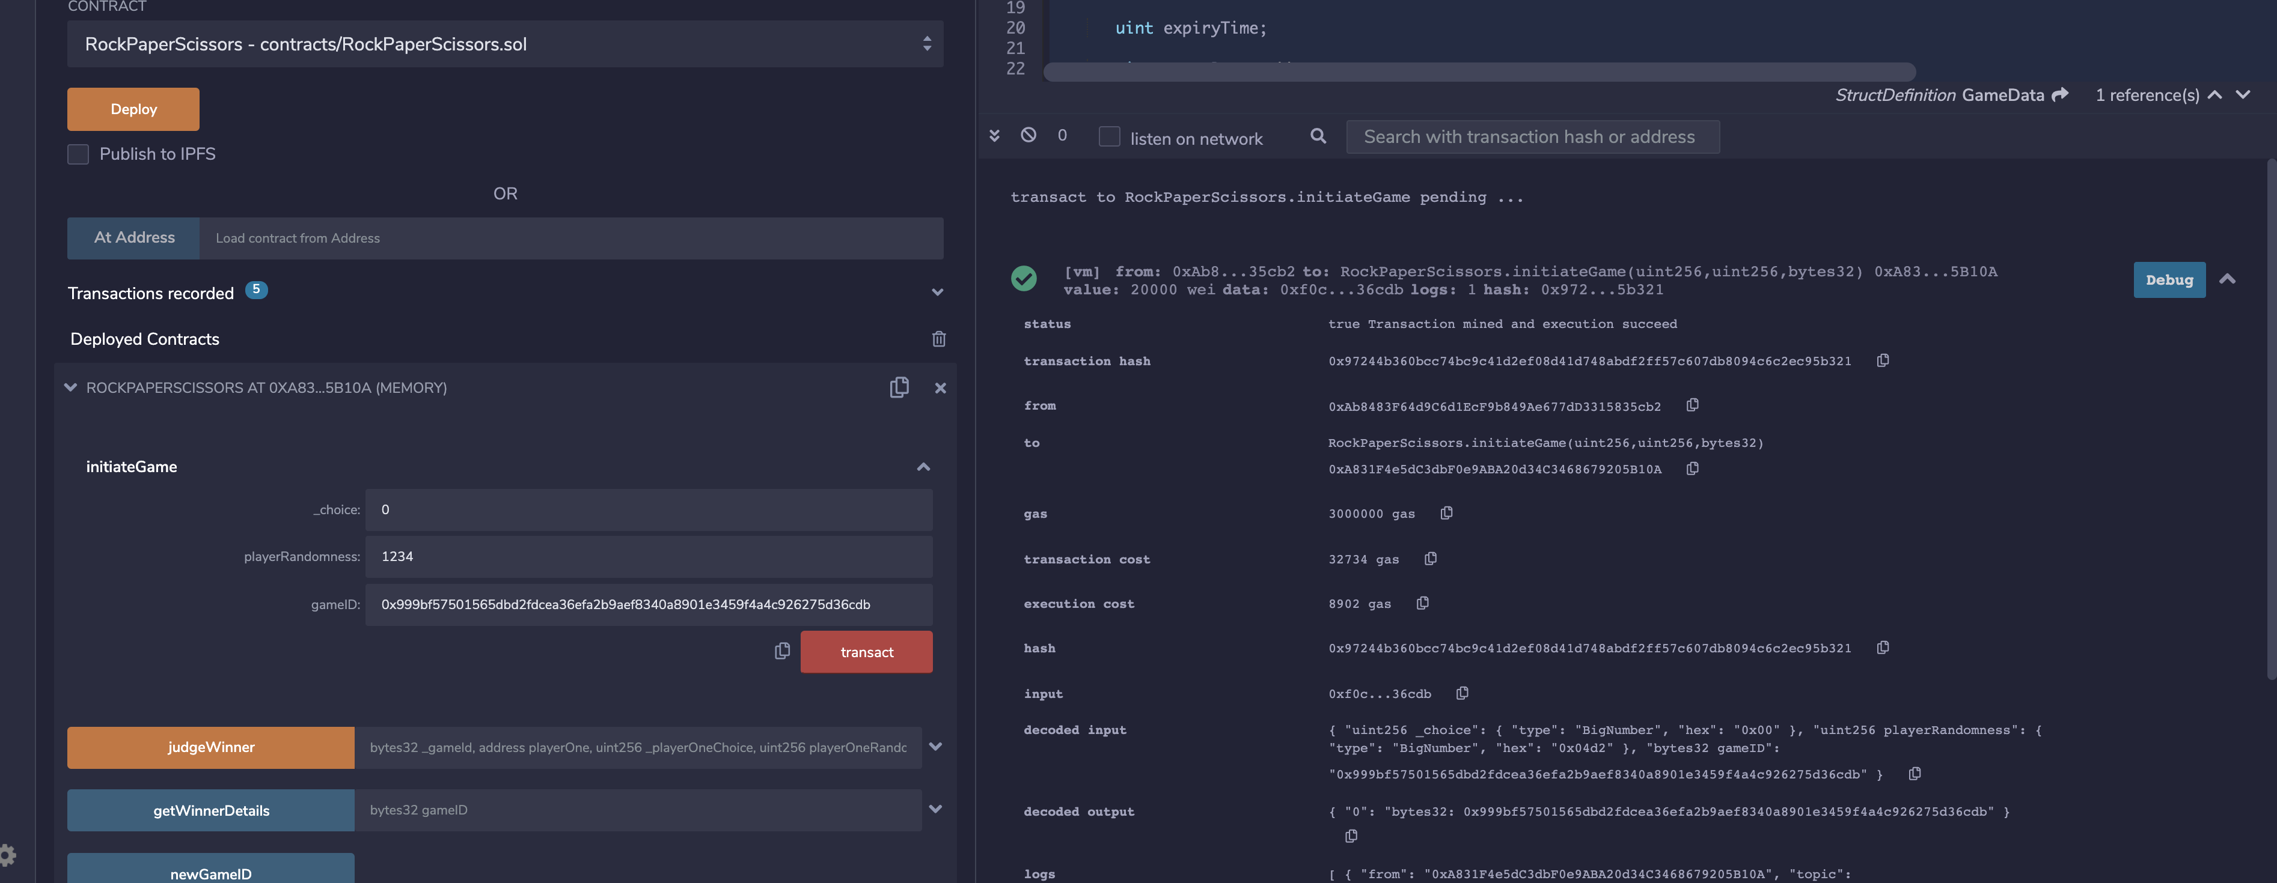

**Player 2 addr** : **0x4B20993Bc481177ec7E8f571ceCaE8A9e22C02db**

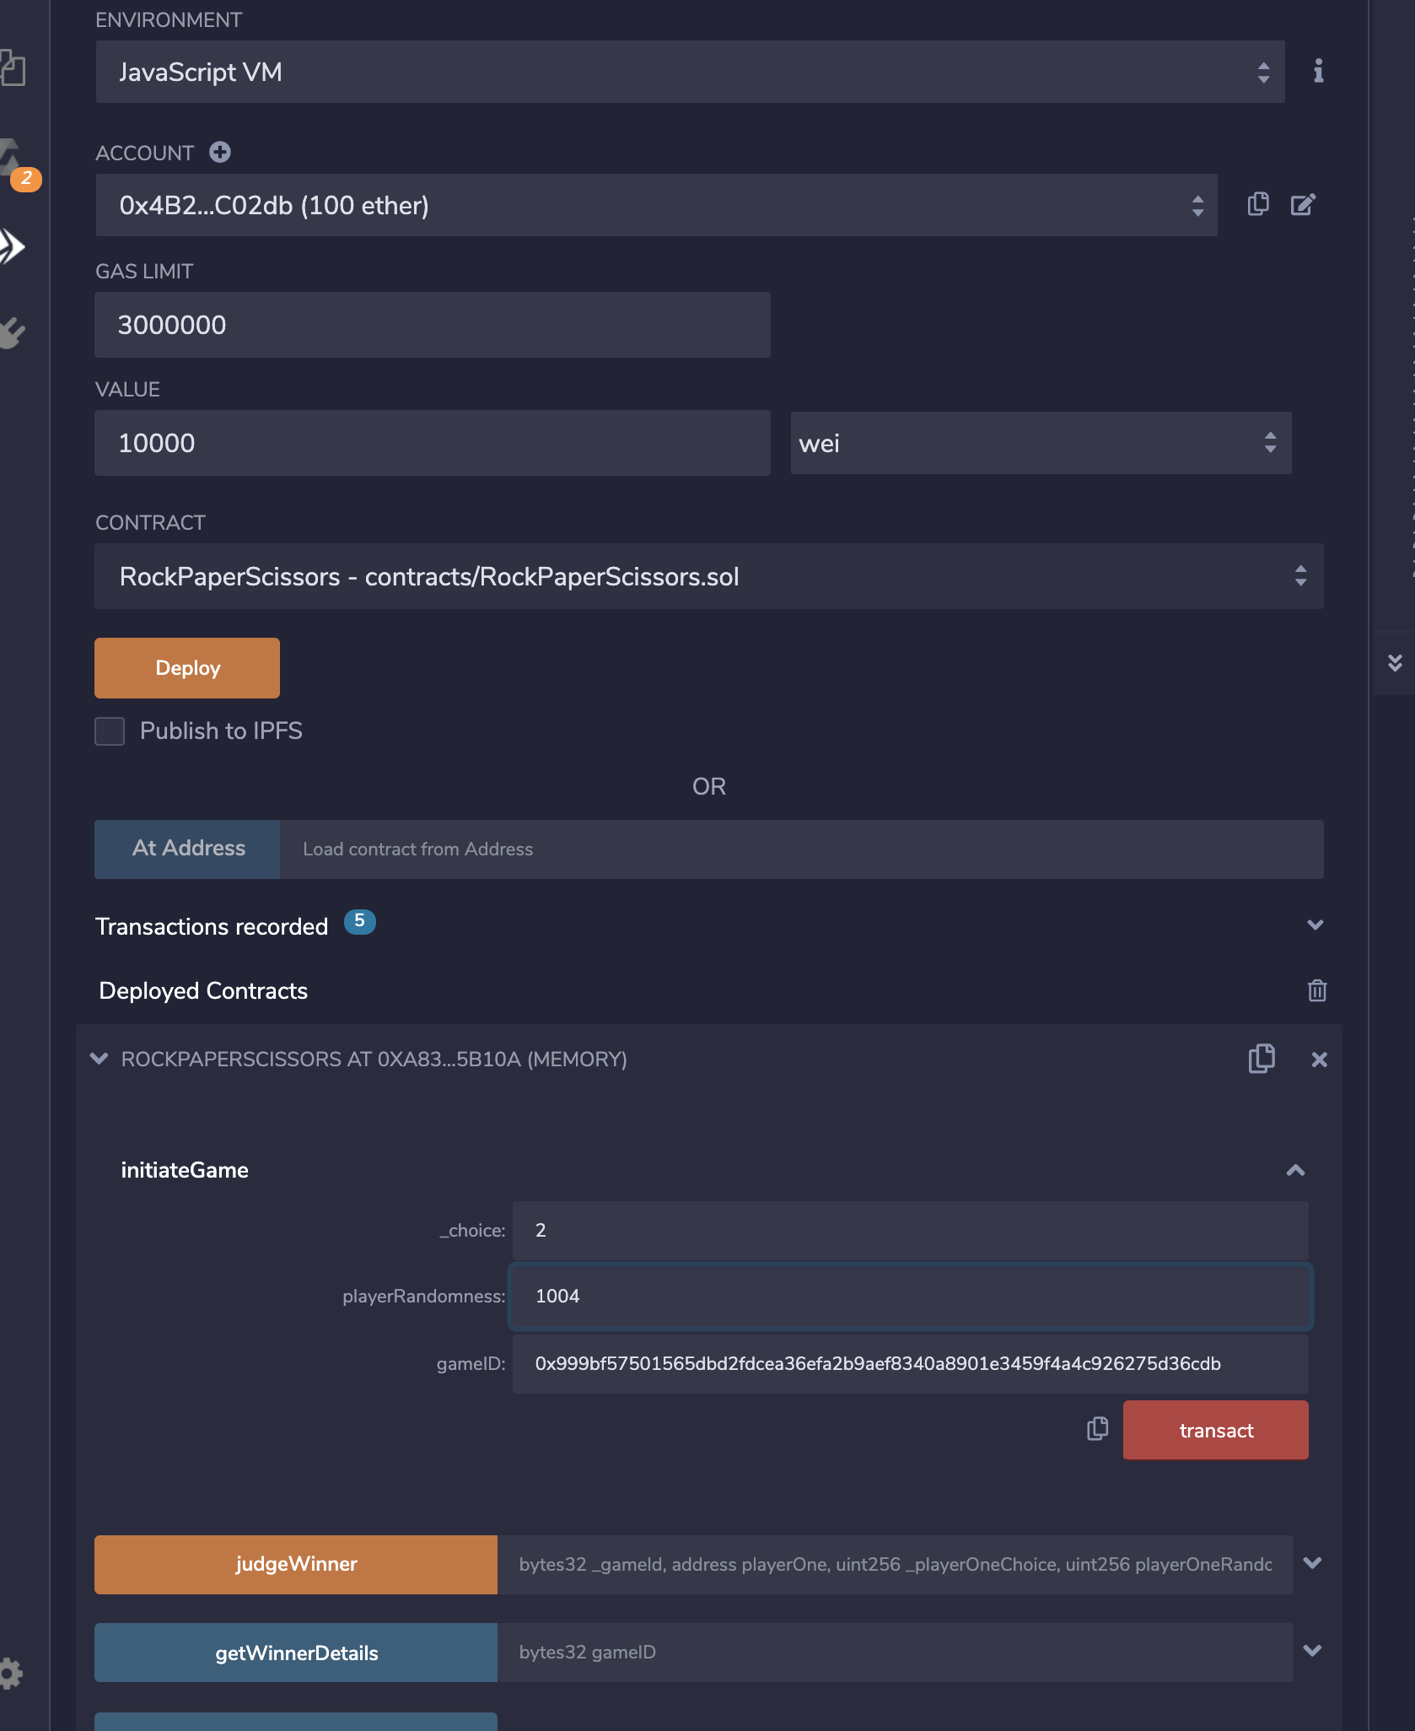

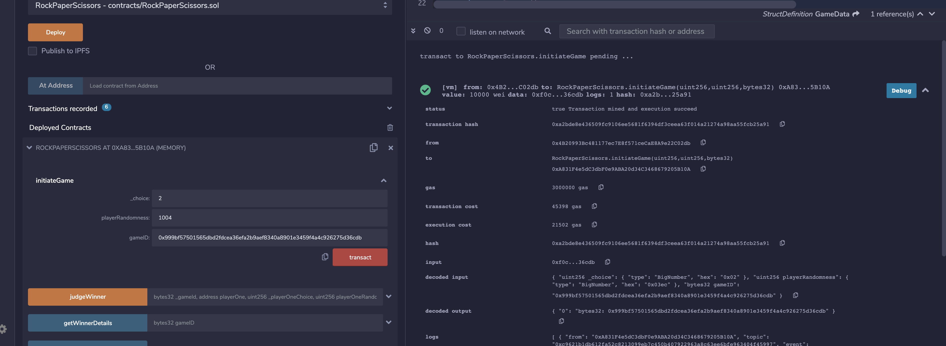

**End game:**

**When we end game from UI, ‘judgeWinner’ gets called.**

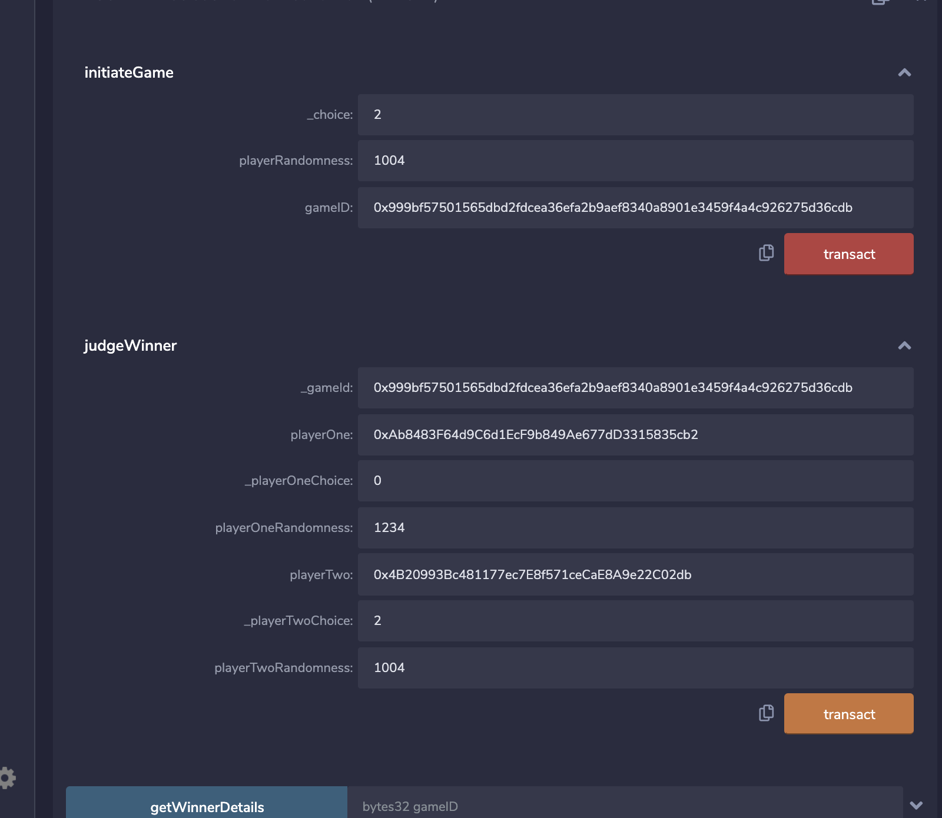

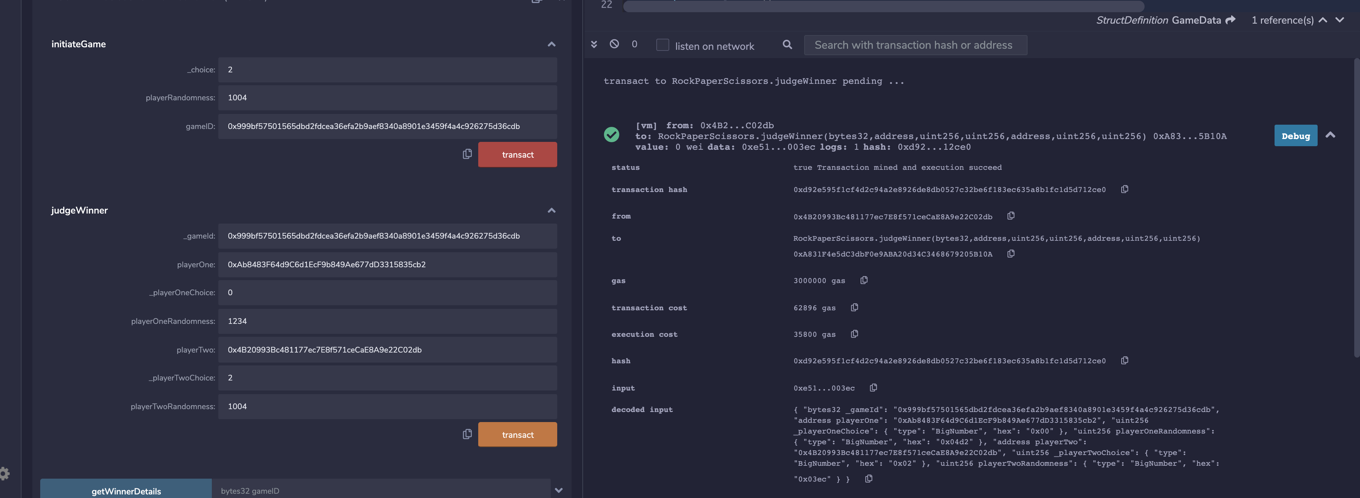

**View result:**

**When we clock on ‘View result’ game from UI, ‘judgeWinner’ gets called.**

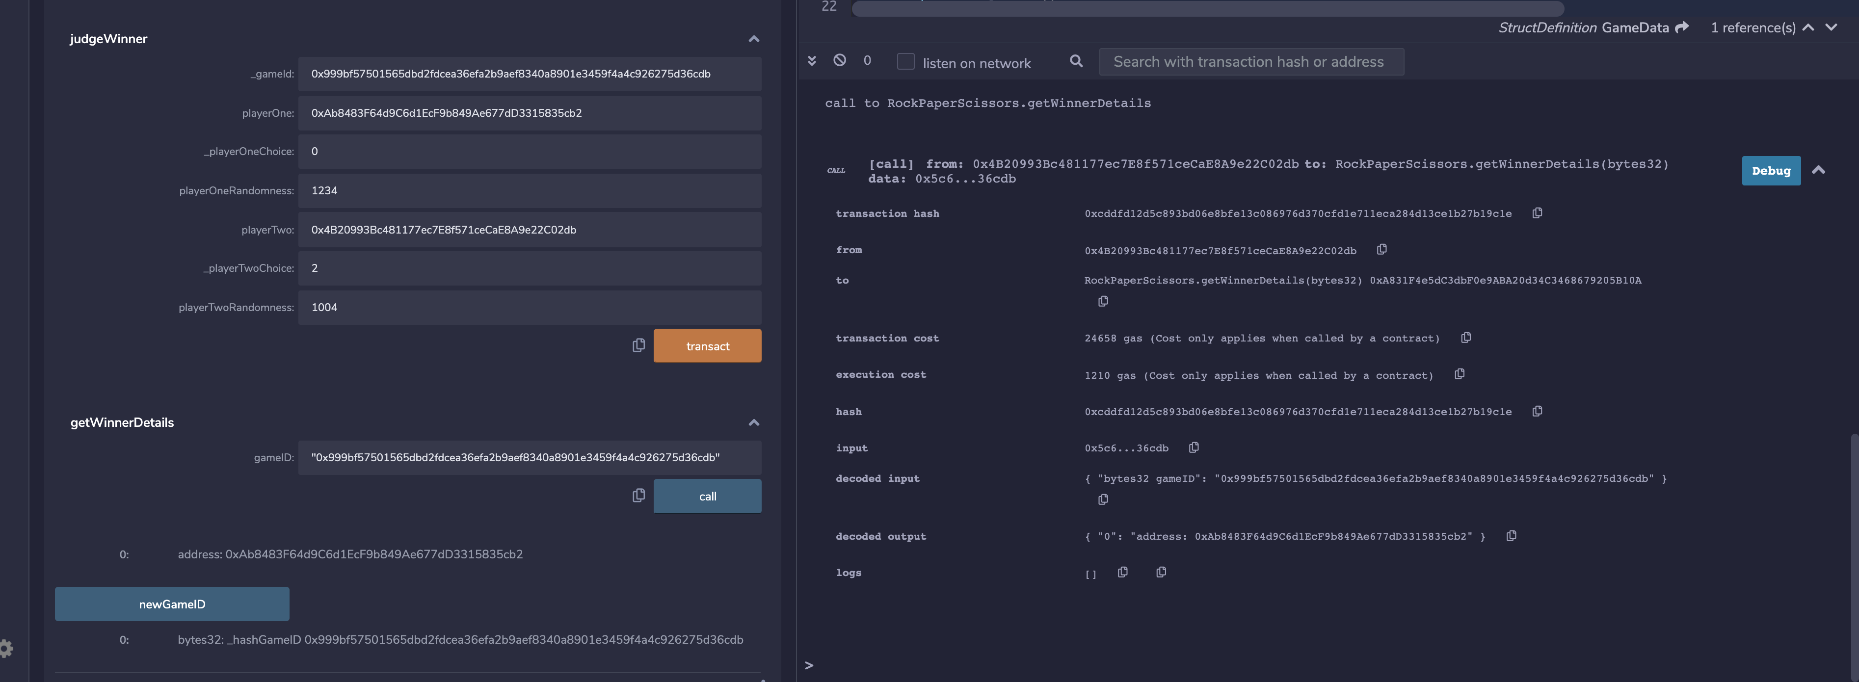

**UI Screenshots:**

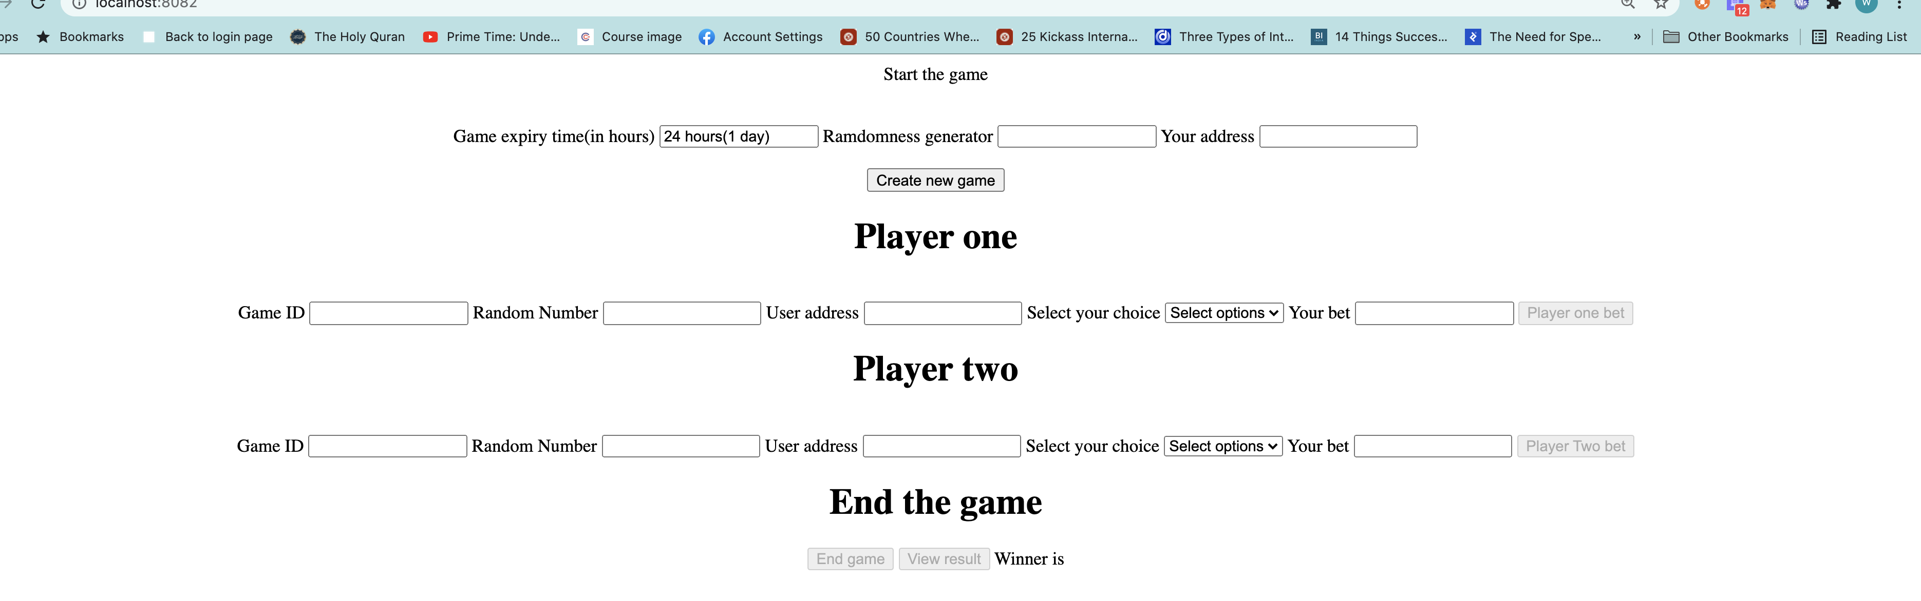

Player one initiated game by generating game id

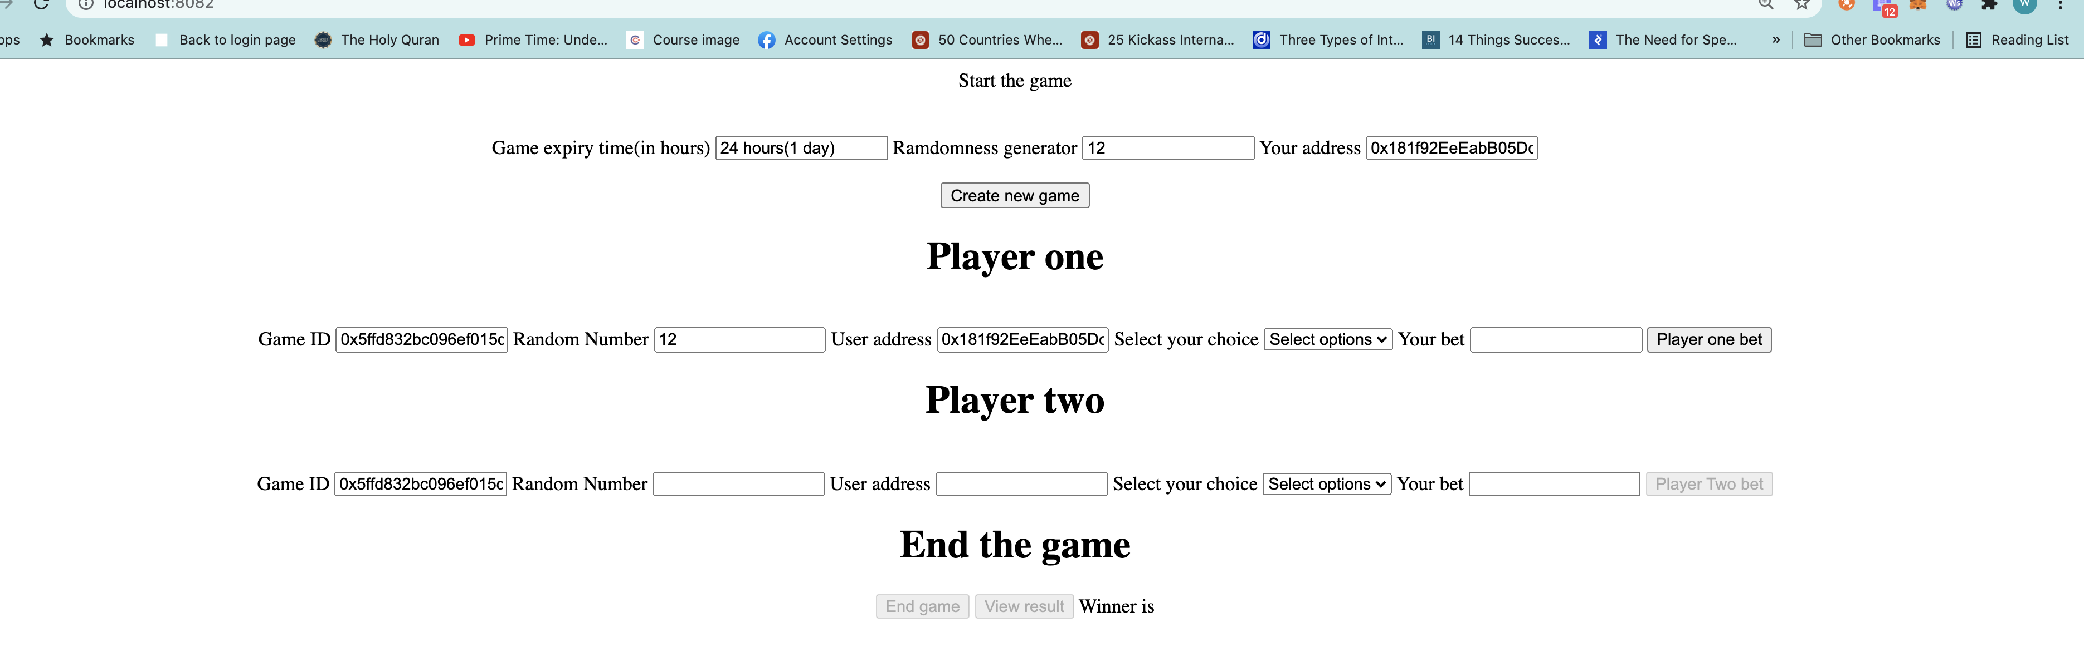

Player one placing bet :

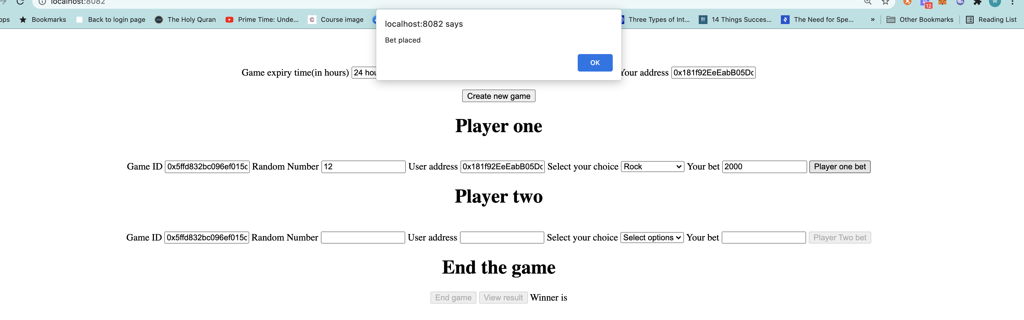

Console log

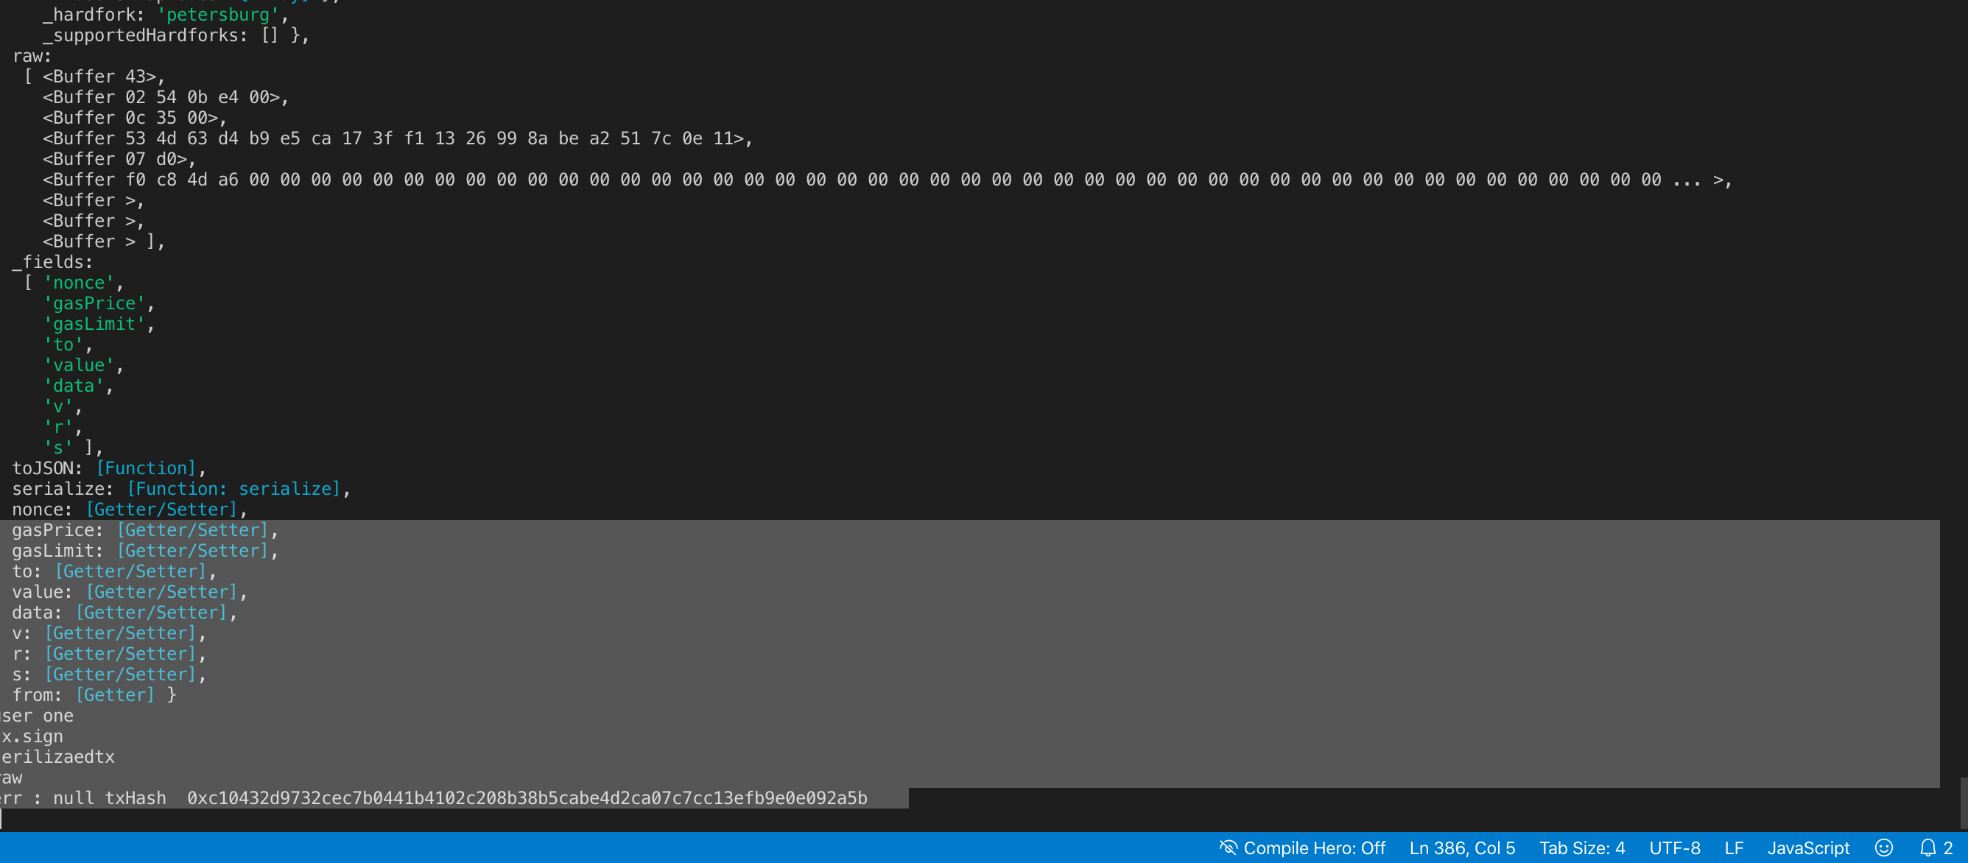

Player 2 placing bet

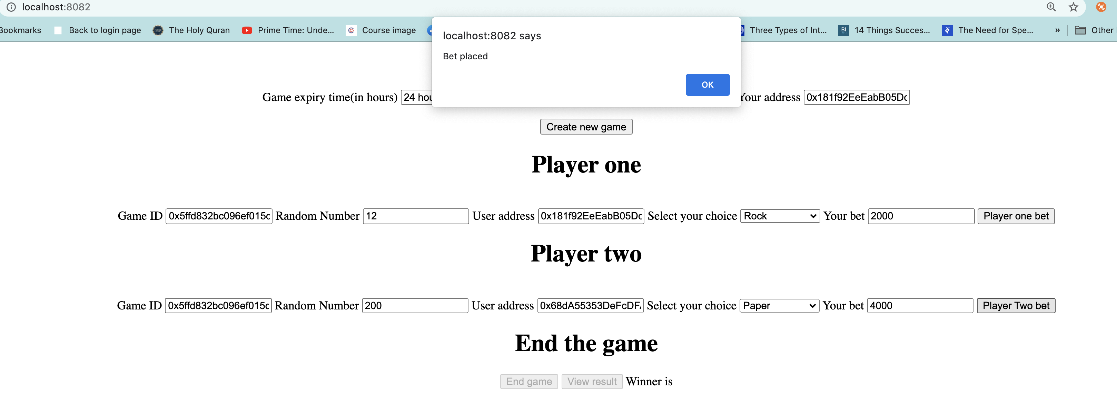

Console log

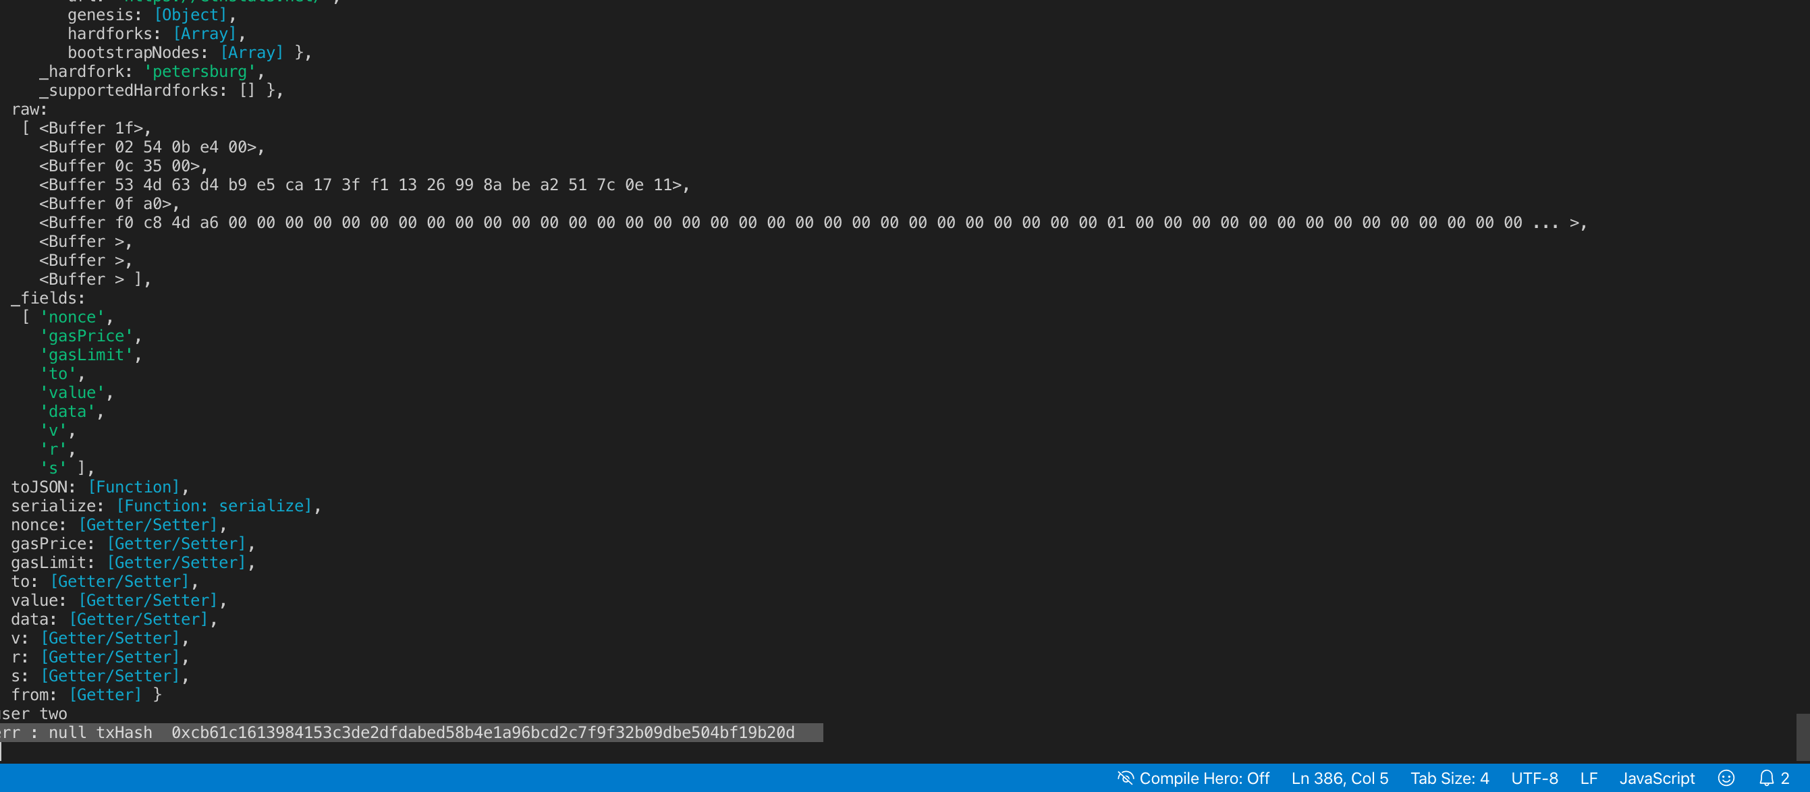

End game:

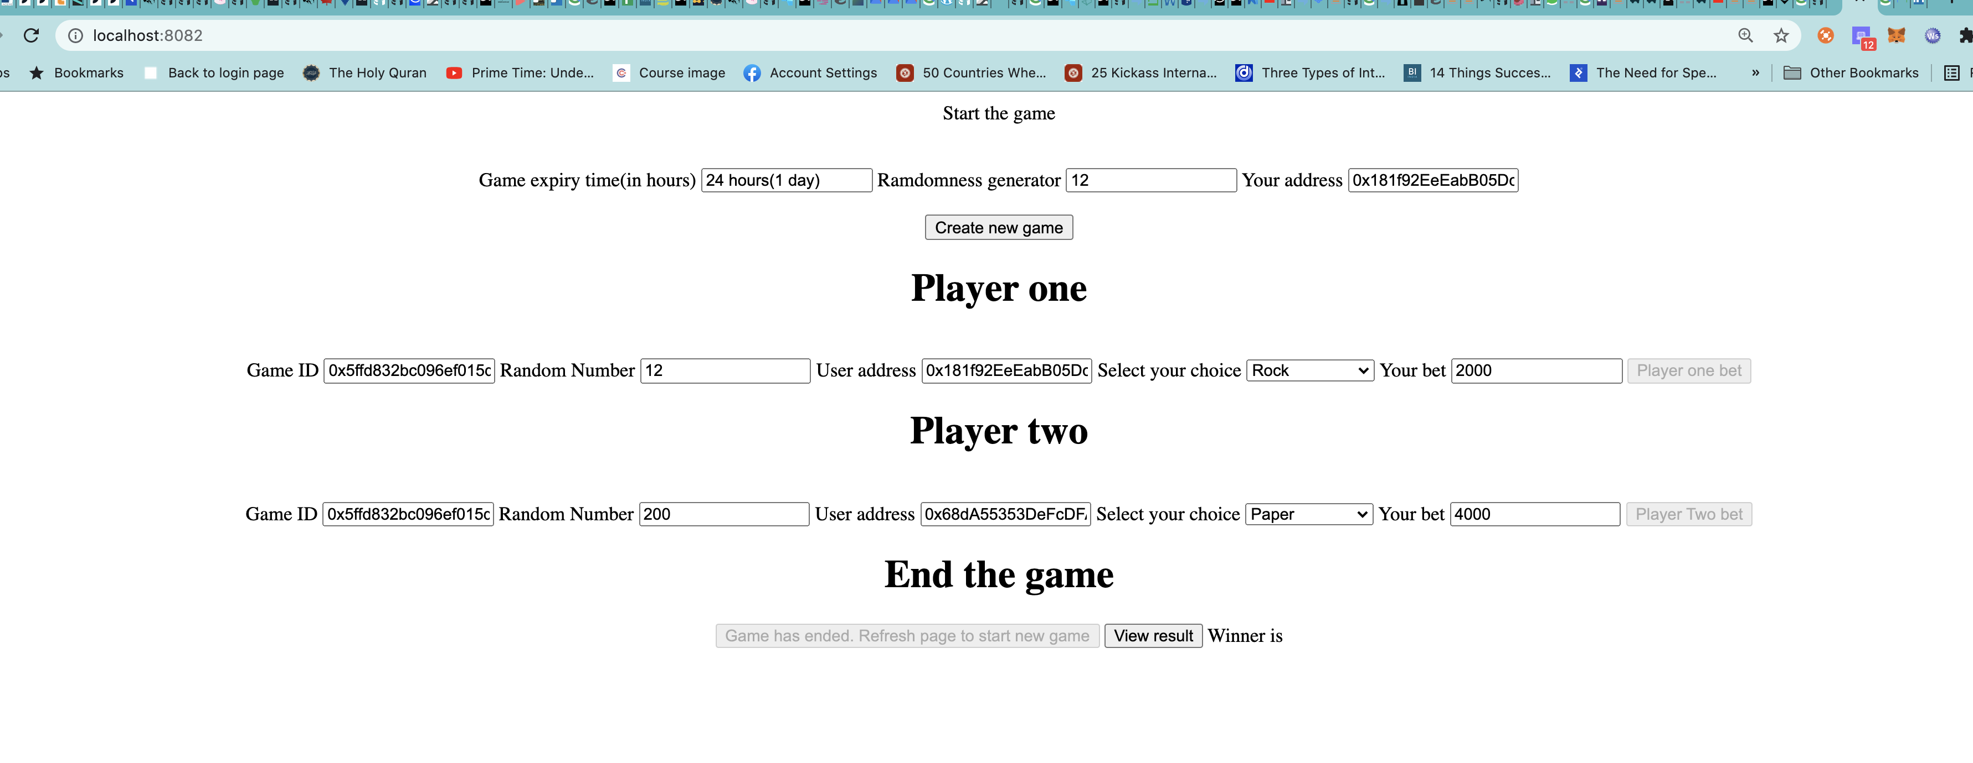

Console log

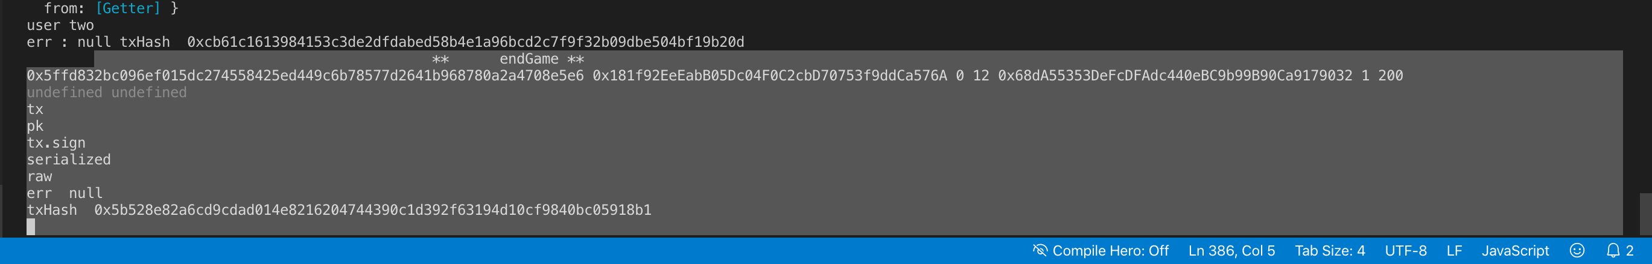

View result :

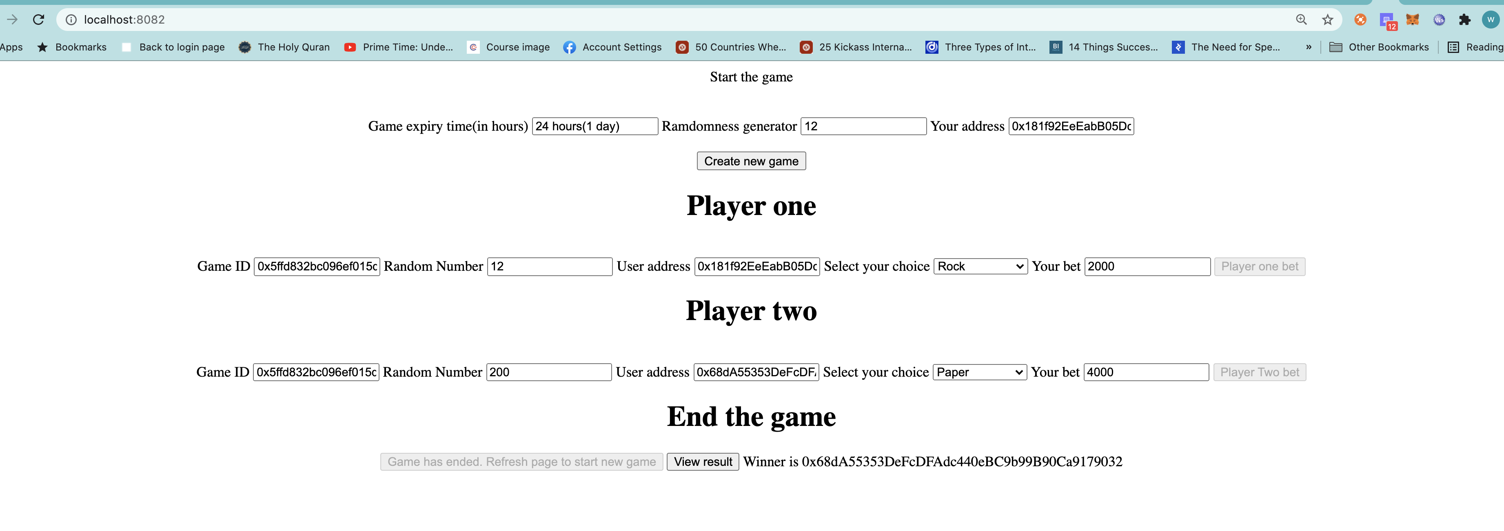

Console log [No log statements were put in method, but no error got logged.]

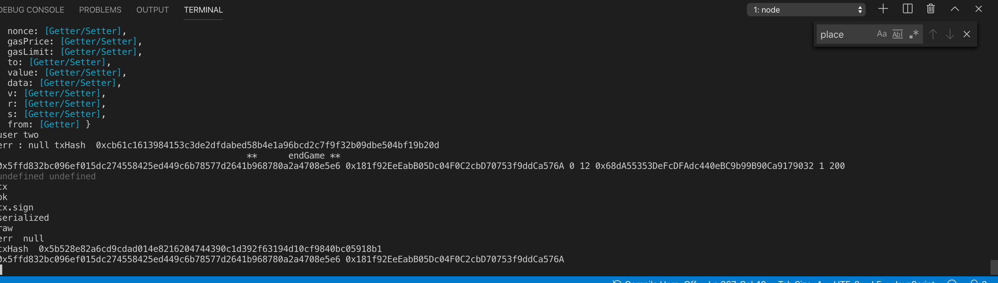

In case of Tie

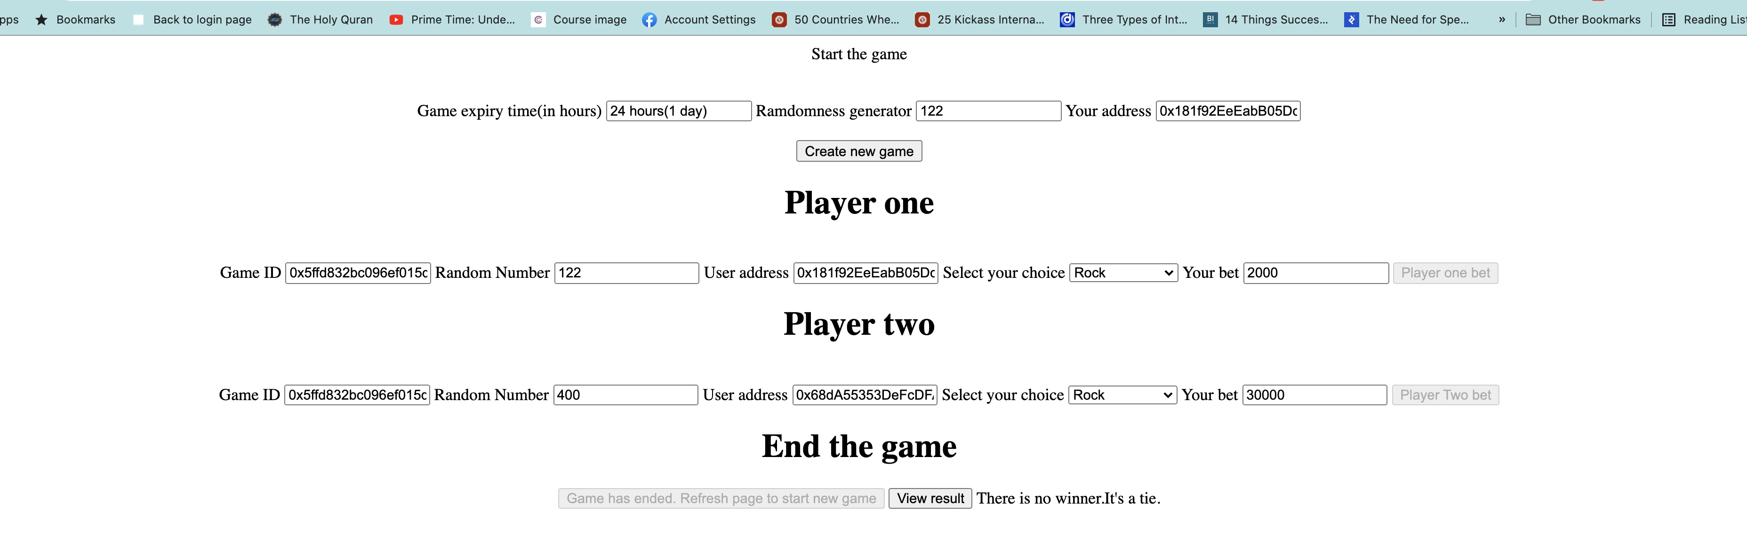

**Contract deployment on testnet[Ropsten]:**

Deployed contract address : 0x18A8c8C3c86ff0C6DFA71CD2a4dD976FbFabb21D

